AEL Technical Blueprint v2.1, Group 3
25 Oct 2026 · final for submission
Platform: AEL Research Platform (Desk Research Agent + LLM wiki) · Team: Group 3 · Authors (Developers): Nikola Hadzhiminov, Tanishq Bhaiji · Version 2.1, 25 Oct 2026 (was 2.0, 21 Oct) · Implements PRD v1.1 · Reason: describes the platform as built; corrects the agent description against its code, adds the LLM wiki as the knowledge store, the monitoring signals and the interview outcome. · Links: agent, LLM wiki, repo, failure log.

1. The platform at a glance
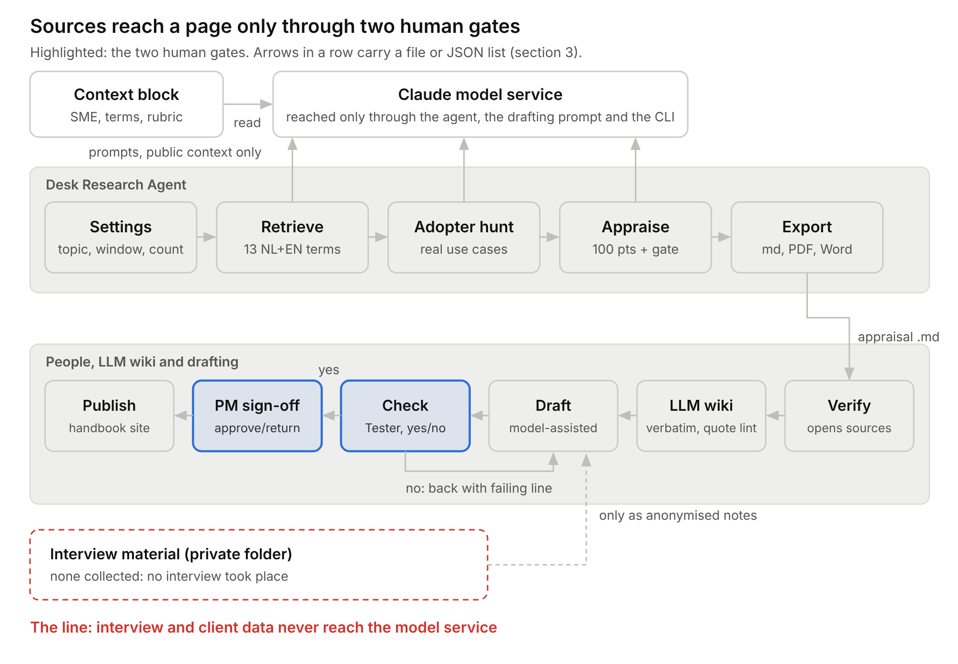
AEL platform · 12 parts, 2 human gates, 1 line

2. The parts
- Context block (code, inside the agent page): default SME context (Thuiszorg Totaal), the 13 search terms, source priority and the rubric, written into the prompts. Retrieve and Adopter hunt receive the SME context; Appraise receives the rubric and the recency window. The default applies when the context box is empty.
- Settings (person, form): topic (or one of 7 presets), recency window of 3, 5 or 10 years, source count of 6, 8 or 10, optional public context → run brief.
- Retrieve (model): run brief → JSON list of sources the model names from its own knowledge, using 7 English and 6 Dutch terms. It does not browse.
- Adopter hunt (model): topic → real-use cases marked independent or vendor-published, or a limitation sentence.
- Appraise (model scores; code applies gate and bands): source list → include/exclude, five scores and a total per source. Code turns Evidence below 15/30 into "Evidence gate failed" and sets the band (80, 60, 40).
- Export (code): results → appraisal file. Markdown is copied to the clipboard; PDF and Word are downloaded.
- Verify (person): appraisal file → corrected file. Every source is opened through its search link; a source that cannot be found is struck.
- LLM wiki (built with the agentic CLI; a person decides what goes in): verified source → raw file kept verbatim plus a source page. Lint compares every quotation with its raw file character by character and flags orphan pages. One source is ingested; the rest are queued in INGEST-QUEUE.md (F9).
- Draft (model-assisted, person edits): verified sources → page in the handbook template, each claim tagged.
- Check (Tester, LLM checklist as aid): draft → check report. PM sign-off (person): report → approved page. Publish (Deployer): page → handbook site.
A model does Retrieve, Adopter hunt and Appraise because judging what evidence a Dutch source holds needs reading; the gate (Evidence below 15/30 cannot be rated good) is a plain rule, so code applies it. Not built: Translate, because no interview took place and there is no Dutch interview material to process.

3. What passes between the parts
Named contract, Export → Verify: appraisal-<date>-<topic>.md (PDF and Word carry the same content). Per included source: title, publisher, type, year, language, search links, the search term that found it, snippet, relevance /25, reliability /20, evidence /30, recency /10, context /15, total /100, verdict band (a failed Evidence gate is shown as the verdict), scoring rationale, use for, not for. Plus excluded sources with reason, and the adopter cases or the limitation sentence. A person can write this file by hand with the same rubric. Inside the agent, Retrieve hands Appraise a JSON list (title, publisher, domain, find_query, language, type, year, snippet, search_term); Appraise returns one JSON row per source, matched back by title.
Verify → LLM wiki: the raw text of a verified source, saved verbatim (Dutch stays Dutch), plus its appraisal row.
Claims keep their sources. Each draft claim carries [source: ID], pointing to one row of the verified appraisal file or one wiki source page. A translated claim keeps its tag. Check is the part that tests the link: the Tester opens the source and finds the passage.

4. The line
Interview recordings, transcripts and anything identifying a Thuiszorg Totaal client or employee never reach a model service. No interview took place, so no such material exists; the rule stands for any later run. It is held at the only three doors to a model: the Settings form (no upload field; the context box takes public facts only), the drafting prompt and the CLI used for the wiki. A person would carry interview material and anonymise it by hand. Outbound flows: Retrieve, Adopter hunt and Appraise send topic, public context and source metadata to the Claude model through the claude.ai page; Draft sends verified sources and the page outline; the CLI sends public source text for the wiki. Nothing else leaves. The agent cannot browse, so web text enters only as material a person saved, never as instructions.

5. Control and failure
Code runs Settings → Retrieve → Adopter hunt → Appraise → Export on one button press; from Verify on, people decide each step (production-line view; roles in the PRD). Before publication the Tester checks every PRD yes/no check, then the PM signs; neither is automated.
On failure: Retrieve error → stage 1 turns red and the run stops; a person reruns up to twice, then works by hand with the week-3 search strategy. Appraise error → stage 3 turns red and the sources are shown unscored (0/100, gate failed); rerun and never use that file. Adopter hunt error → stage 2 turns red, the run continues and the results carry no adopter section; Verify writes "adopter hunt not run" into the file. A source fails Verify → struck, never repaired by the model. A "no" in Check → back to the Developer with the failing line, not to the model, because the fault may be in the source; after 2 rounds the PM drops or rescopes the section.
Monitoring: how the platform says it is failing, drifting or making things up. Failing: each stage turns red with the error, and a details panel prints the permission and connection state (F8). Drifting: the Tester compares the agent's bands with her own each run; agreement reached at least 6 of 8 (PRD A3). Making things up: no model-made URLs (F6); Verify opens every source; wiki lint fails on any quotation that does not match its raw file, tested by altering one quote (F10). Known gaps: the agent does not check that a named source exists, does not recompute the total from the five scores, and shows a source as unscored if the model rewords its title in Appraise. Each is caught only at Verify (failure log F12–F14).
Manual fallback: every automated part produces a file a person can write by hand with the same terms and rubric. Run record: each exported file is saved to the repo. The file records the topic but not the date or settings, so the person names it appraisal-<date>-<topic> and notes recency window and source count in the commit message.

6. Trace to PRD v1.1
Journey steps 1–4 → Settings, Retrieve, Adopter hunt, Appraise, Export. Step 5 → Verify. Step 6 → LLM wiki. Step 7 → Draft. Step 8 → Check and PM sign-off. Step 9 → Publish. Yes/no checks → Check. The line → section 4. Manual fallback → section 5. Departures: Adopter hunt and Export added (in the PRD since 1.0); LLM wiki added as the knowledge store (PRD 1.1); Check moved from an automated part to the Tester, since a model grading its own draft is no check; Translate dropped, because no interview took place.

7. Decisions and open questions
- No model-made URLs (contract), not full links: costs one search click per source (F6).
- Evidence gate as a hard rule, not ranking on total only: useful vendor pages can only describe, never prove.
- Wiki holds verbatim text only, not web-fetch summaries: the quote check stays meaningful, but only one source is ingested so far (F9).
- Failed checks go to a person (control), not to automatic rewrites: slower, needs a free team member.
- Agent as a claude.ai page using the sample capability, not a full CLI pipeline: anyone on the team runs it without a terminal (F5, F8); run records are saved by hand.
Resolved: O1 Build Translate? No; no interview took place. O2 Band agreement ≥6 of 8? Yes (Valentina). Open: O3 Does the site take Markdown by push or paste? Tanjin, before final publish. O4 Ingest the queued wiki sources on a team machine (Nikola, Tanishq).

